**Gini Impurtiy:**

Instead of entropy we’ll calculate Gini Impurity, as computationaly it takes less time than entropy because here we are just taking square there we need to do log of probabilities.

How Gini Impurity is calculated is given below.

Case 1: when both +ve and –ve are in equilibrium

Gini imp = 0.5 and entropy = 1

Case1: when +Ve is 100% and –ve is 0.

Gini imp = 0 and entropy = 0

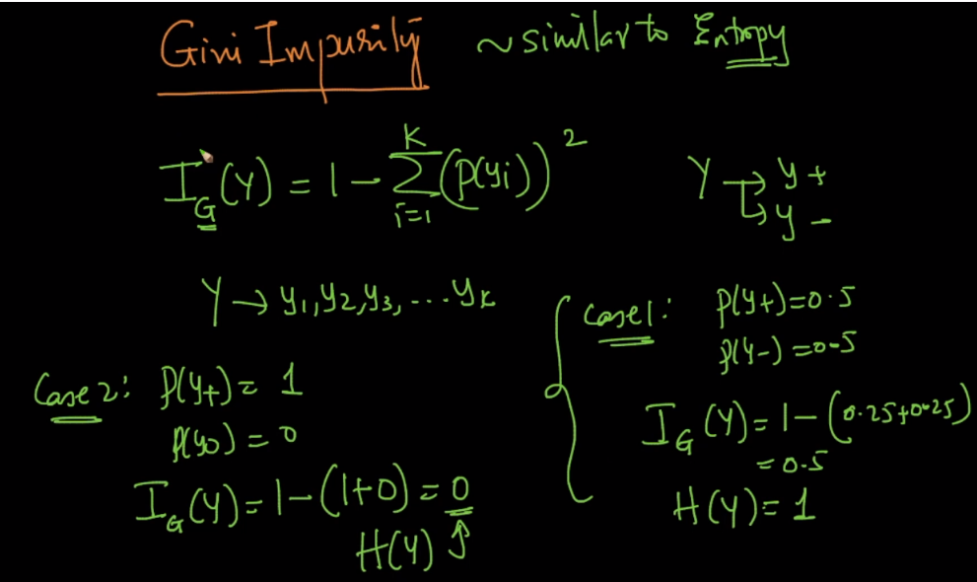

If we make a plot of gini impurity and entropy we will see that both have similar kind of plot, the only difference is that the highest value of gini impurity is 0.5 and for entropy is 1.

Except this both have similar properties, as we move away from p(y) = 0.5, both gini imp and entropy start decreasing.

